**Creating Time-Lapse Map of Yelp Reviews In Microsoft Excel**

**By: Team 3 - Michael Brumwell, Marco Rodriguez, & Chris Alipio**

**Created: 12/14/2019**

**Objective:**

We will upload our data to Hadoop, then use Pig to create tables and export our results as a CSV file.

**Using Excel:**

After you download our data from our GitHub found here - <https://github.com/alapacho/CIS-4560-Project-Group-3.git> - (in the “time visual” folder) your data should look like this:

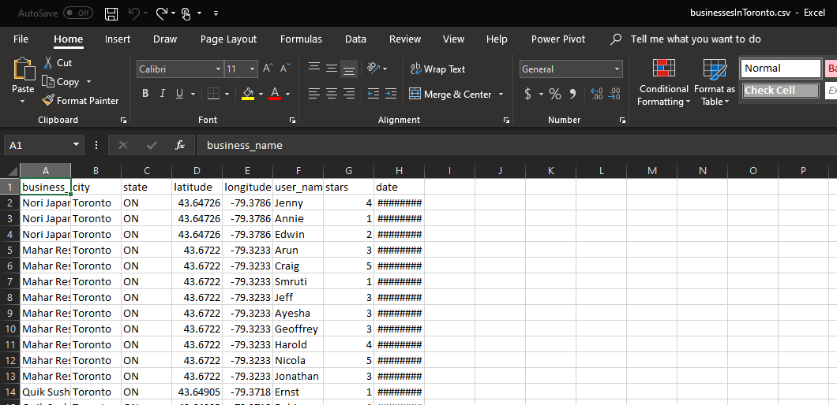

There should be **1056 rows** not including the first row, which are the names for the headers.

1. Expand the date column to see more details by double-clicking on the line shown below:

(Before clicking on this line)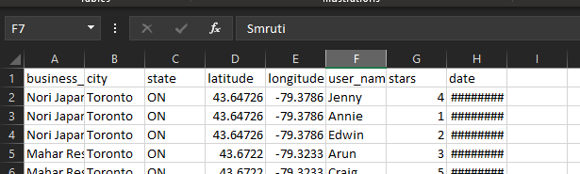

(After clicking on this line)

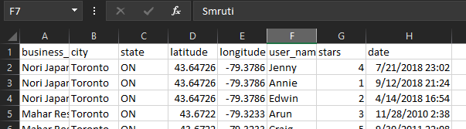

1. Click on one of the filled cells to highlight it, then press “CTRL + A” to select all the filled cells:

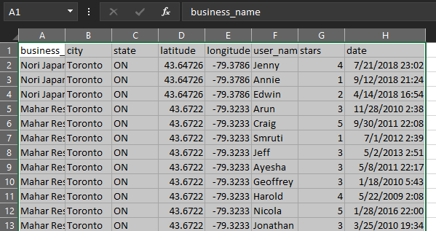

1. On the Home tab, select “Format as Table” then pick a color of your choosing. I picked green for this tutorial:

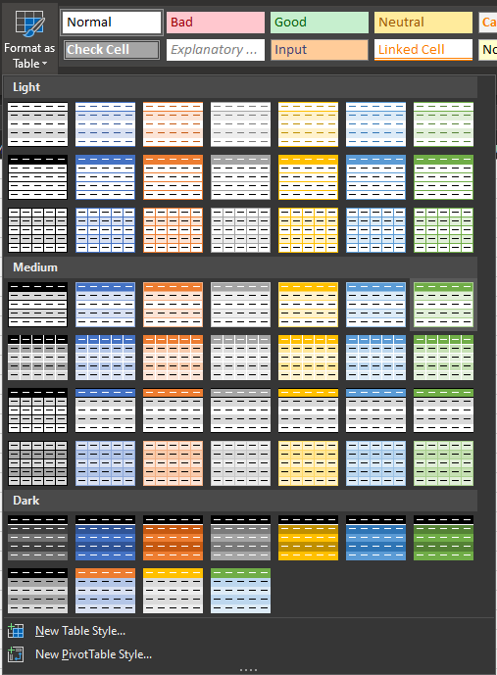

1. A small window will appear. Leave everything as is and click “OK”.

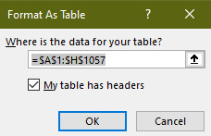

1. When the Excel file is saved as a CSV file, you will not be able to create a Time-Lapse/ 3D Map. Click “File”, then “Save As”

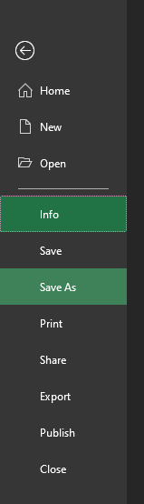

1. Next, save the file as an Excel Workbook (.xlsx) file:

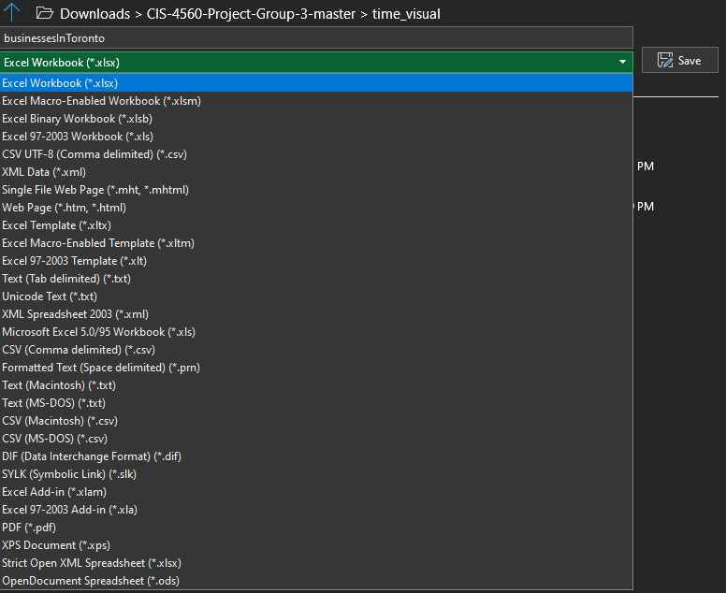

1. The ability to create a Time-Lapse/ 3D Map should be available. Go to the “Insert” tab and select “3D Map”, then select “Open 3D Maps”.

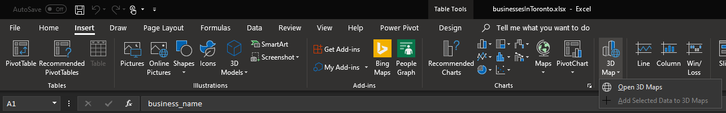

1. Your map should show a small cluster of datapoints in Toronto, Canada. Zoom in on that city to see more details:

(Before zooming in)

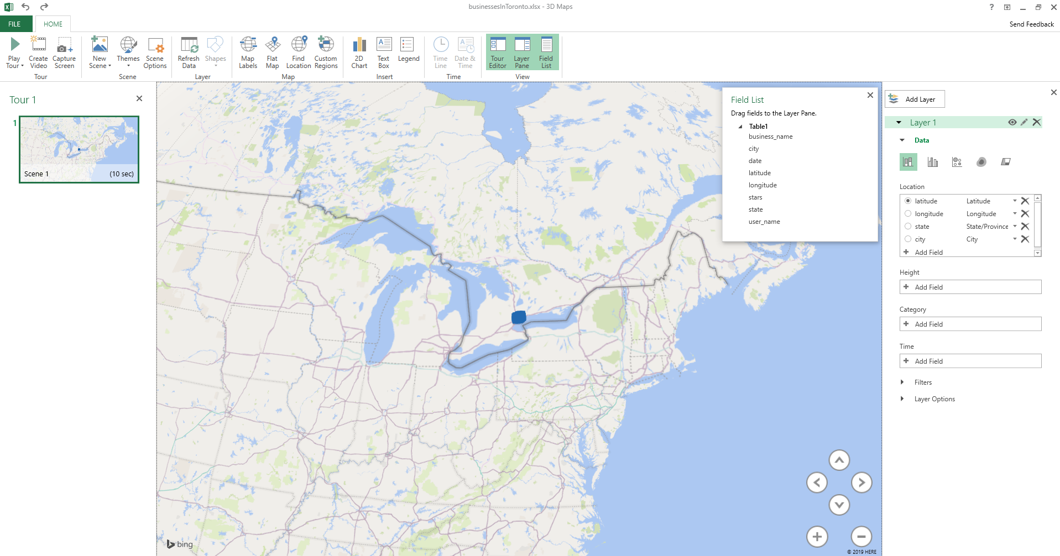

(After zooming in)

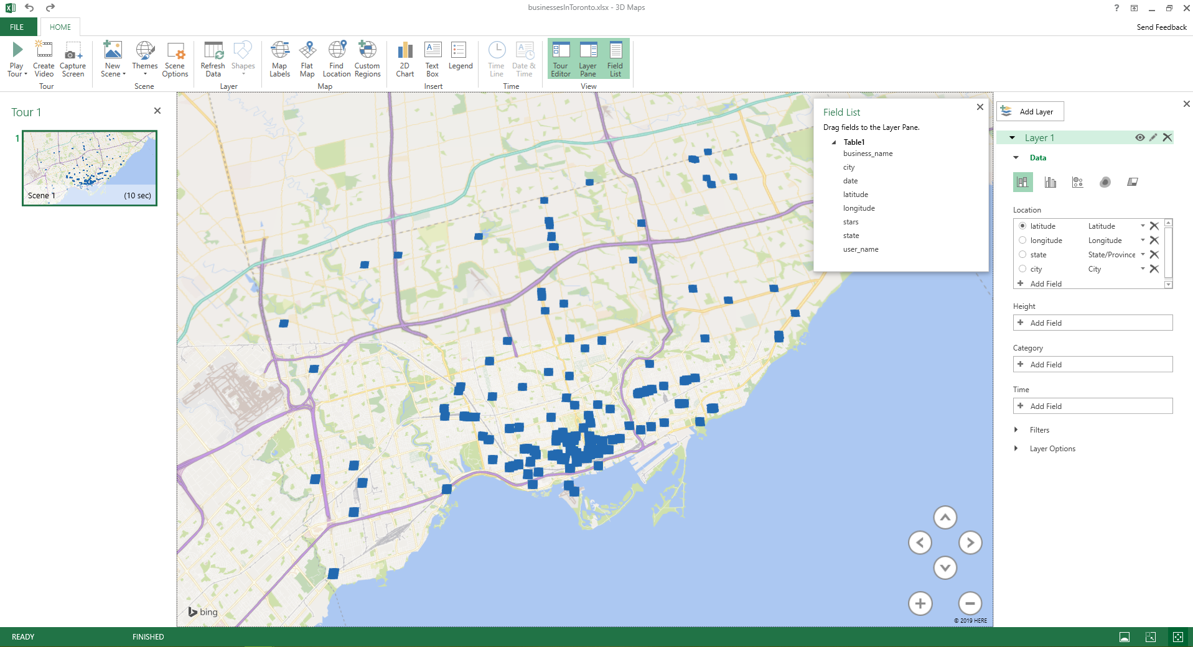

1. On the right-hand side under “Layer 1”, go to “Time” and click on “Add Field”, then click on “date”

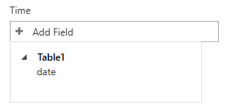

1. For this dataset, we have time-based Yelp reviews created by the minute, so select the “date” dropdown and select “Minute”:

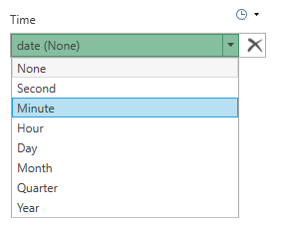

1. After that, click the “Play” button on the top-left hand portion of the Excel file. 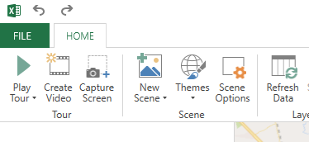
2. A short video showing the creation of Yelp reviews from various restaurant locations in Toronto, Canada will play from September 2008 to November 2018. The completed Time=Lapse map should look like this:

